**Code LPC de Brigitte Bigi**

# ---------------------------------------------------------------------------

#

# This is the description file fra.txt, made by Brigitte Bigi.

# It defines the phonemes, their classes, and their keys in the LfPC code.

#

# If you intend to change this file, please read SPPAS documentation before!

#

# Use of this file is governed by the GNU Public License, version 3.

# This banner notice must not be removed.

# Copyright (C) 2011-2020 Brigitte Bigi, Laboratoire Parole et Langage

#

# ---------------------------------------------------------------------------

#

# A syllable is always coded with a C-V sequence.

# The vowel is represented by a position on the face, and the consonant

# by an hand key.

#

# Example of use:

# The word "Bonjour" is phonetized /b-O~-j-u-R/

# It is syllabified /b-O~.j-u.R/ then converted to keys:

# /b-O~/ = 4-4

# /j-u/ = 7-2

# /R/ = 8-0

# The first key always refers to a consonant and the second to a vowel.

#

# ---------------------------------------------------------------------------

# By convention in this configuration file:

#

# - cnil substitutes a missing consonant.

# It will be used when there's no consonant before the vowel.

#

# - vnil substitutes a missing vowel.

# It will be used when there's no vowel after a consonant.

# ---------------------------------------------------------------------------

# ---------------------------------------------------------------------------

# Here is the list of phonemes and their class.

# ---------------------------------------------------------------------------

# A phoneme/class definition is made as 3 columns:

# - first column is the key-word "PHONCLASS";

# - second column is the phoneme;

# - third column is the class-symbol.

#

# It is important to note that:

# - a vowel has to be mentioned with the class-symbol "V";

# - a consonant has to be mentioned with the class-symbol "C";

# - the class-symbol for a break is "#".

# The filled pause is not coded, it is considered a break.

PHONCLASS fp #

# List of French vowels, use V symbol

PHONCLASS i V

PHONCLASS e V

PHONCLASS E V

PHONCLASS a V

PHONCLASS A V

PHONCLASS O V

PHONCLASS o V

PHONCLASS u V

PHONCLASS y V

PHONCLASS 2 V

PHONCLASS 9 V

PHONCLASS @ V

PHONCLASS e~ V

PHONCLASS E~ V

PHONCLASS a~ V

PHONCLASS o~ V

PHONCLASS O~ V

PHONCLASS 9~ V

PHONCLASS U~ V

PHONCLASS EU V

PHONCLASS eu V

PHONCLASS oe V

PHONCLASS U~/ V

PHONCLASS A/ V

PHONCLASS O/ V

# Vowels added for Quebec French

PHONCLASS 3 V

PHONCLASS A~ V

PHONCLASS I V

PHONCLASS U V

PHONCLASS Y V

# List of French consonants

PHONCLASS j C

PHONCLASS H C

PHONCLASS w C

PHONCLASS l C

PHONCLASS R C

PHONCLASS r C

PHONCLASS p C

PHONCLASS t C

PHONCLASS k C

PHONCLASS b C

PHONCLASS d C

PHONCLASS g C

PHONCLASS ? C

PHONCLASS n C

PHONCLASS m C

PHONCLASS N C

PHONCLASS J C

PHONCLASS s C

PHONCLASS S C

PHONCLASS z C

PHONCLASS Z C

PHONCLASS v C

PHONCLASS f C

# ---------------------------------------------------------------------------

# Must not be modified:

PHONCLASS cnil C

PHONCLASS vnil V

# ---------------------------------------------------------------------------

# Here is the list of key codes

# ---------------------------------------------------------------------------

PHONKEY cnil 5

PHONKEY vnil 0

PHONKEY A/ 3

PHONKEY a 3

PHONKEY A 3

PHONKEY @ 1

PHONKEY a~ 4

PHONKEY A~ 4

PHONKEY i 4

PHONKEY e 5

PHONKEY E 2

PHONKEY 2 1

PHONKEY U~/ 5

PHONKEY 9 3

PHONKEY O/ 2

PHONKEY O~ 4

PHONKEY o~ 4

PHONKEY u 2

PHONKEY y 5

PHONKEY b 4

PHONKEY d 1

PHONKEY f 5

PHONKEY g 3

PHONKEY H 4

PHONKEY j 7

PHONKEY k 6

PHONKEY l 2

PHONKEY m 5

PHONKEY n 4

PHONKEY p 1

PHONKEY R 8

PHONKEY r 8

PHONKEY s 8

PHONKEY S 2

PHONKEY t 5

PHONKEY v 6

PHONKEY w 2

PHONKEY z 6

PHONKEY Z 1

Clés

0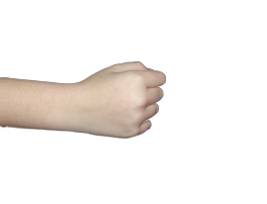1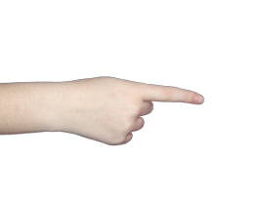23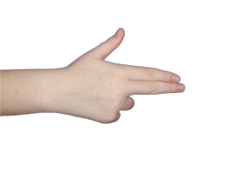

4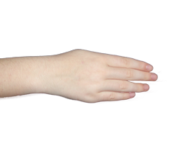5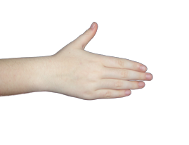6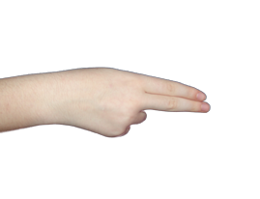7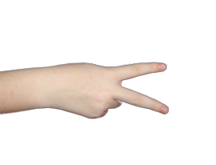

8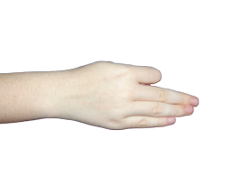

Positions visage > je ne sais pas